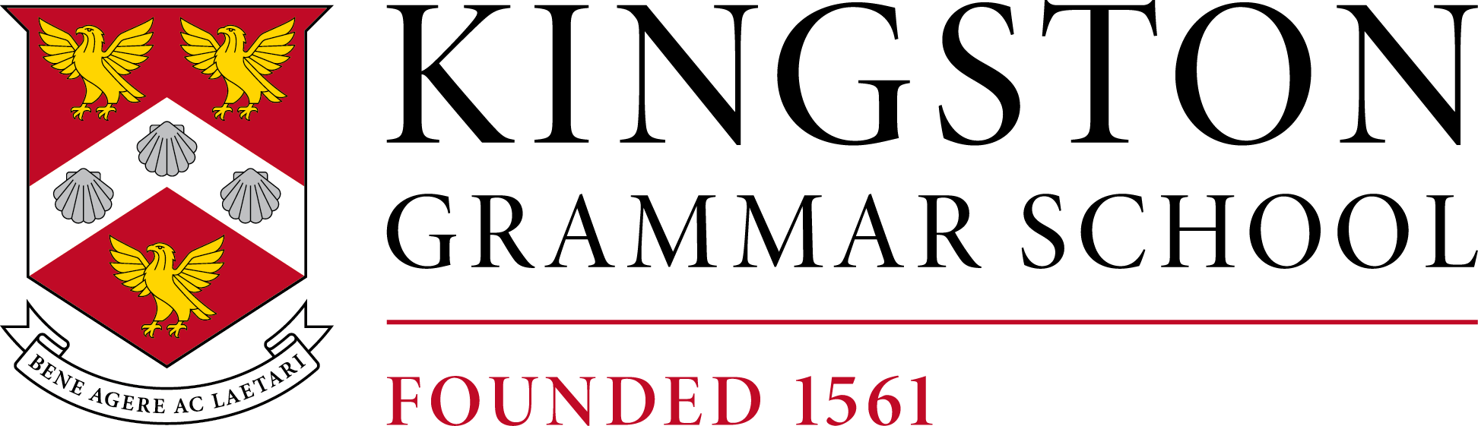**A Leading HMC Selective Co-Educational Day School.**

Kingston Grammar School is one of the most successful co-educational schools in the country and has a long tradition of developing individual talent and encouraging high aspirations. Our students are bright and enthusiastic; their joy in life and spirit of curiosity makes education here a real pleasure.

SCHOOL NURSE

Term time only, 40 hours per week – Monday to Friday, 36 weeks per year

We are recruiting a qualified and experienced Nurse (RGN/RN and RSCN with NMC registration) to support our Lead School Nurse in looking after the health requirements of our student body.

The role is a hybrid of clinical work; triage, treatment and first aid provision alongside medical administration and advising students on health and wellbeing. Experience in the management of minor illness and injury as well as an interest in diabetes, asthma, and [anaphylaxis](https://www.google.com/search?safe=active&sca_esv=f07dd38fdcfe8355&sca_upv=1&q=anaphylaxis&spell=1&sa=X&ved=2ahUKEwjC9K3z8uKGAxWQ_rsIHc9eAG8QkeECKAB6BAgOEAE) would be advantageous.

You will need to demonstrate excellent communication, organisational and administration skills together with experience of working professionally, competently and autonomously within your capabilities, knowing when and where to access support and advice.

The role will offer the right candidate an excellent opportunity for a work/life balance and the opportunity for further career progression and continued professional development. This is a varied and interesting role with the opportunity to develop ongoing relationships with the student body, staff, and the wider school community.

The hours of work are 40 per week, Monday to Friday during the school term time, with up to 10 additional days to be worked in the school holidays. The exact hours of work have some flexibility and can be discussed at interview.

The closing date for the position is 9 am on Monday 1st July 2024 We reserve the right to close this vacancy and interview at any time, therefore early applications are welcomed.

Prior to interview, an online search will be conducted to identify any past or current incidents or issues that might affect your suitability to work with children and undertake this role. This is in line with guidance in Keeping Children Safe in Education. Please note this online search will be carried out only on publicly available information and be limited to issues relating to your suitability to work with children and/or in a school environment. Issues that arise will not automatically be a bar to your employment at this school.

Kingston Grammar School is committed to safeguarding and promoting the welfare of children and young people and expects all staff and volunteers to share this commitment. Applicants will be required to undergo child protection screening appropriate to the post, including checks with past employers and the Disclosure and Barring Service (DBS).

Registered Charity No. 1078461